**User guide:**

**Header menu:**

This section is the same on all pages; from here users can easily jump into any categories at any time or return to the homepage by clicking on the name of the elements in the menu which they are interested in.

***Figure – 1***

*(Users move to List product page by hovering on* ***Menu*** *and clicking on* ***Pizza, Garlic Breads ...****)*



***Figure – 2***

*(Users download menu in image format by clicking on* ***Menu Download****)*



***Figure – 3***

*(Users move to Store Location page, Location, Feedback, Franchise by clicking on* ***Store Location page, Location, Feedback, Franchise****)*



***Figure – 4***

*(Users move to Combo page, Weekend special page, Gallery page, Feedback page, Store location by clicking on* ***Combo, Weekend, Gallery, Location****)*



***Figure – 5***

*(Users move to Shopping cart page by clicking on* ***The icon;*** *Users show list product in cart by clicking on* ***The icon*** *)*

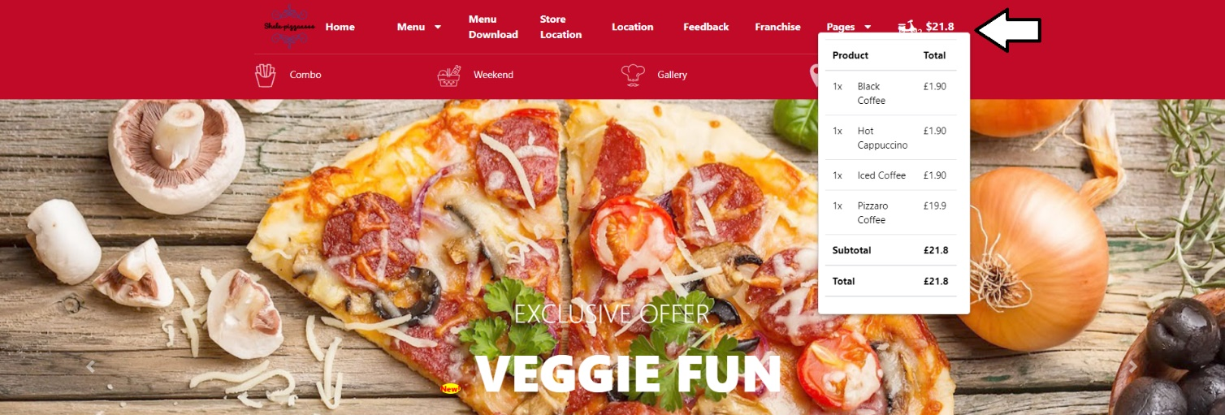

**Homepage content:**

This section show some best products; from here users can easily jump into single product page of special product by clicking on blocks where the product information is showed.

***Figure – 1***

*(Users change to Category of products by clicking on* ***icon or text****)*

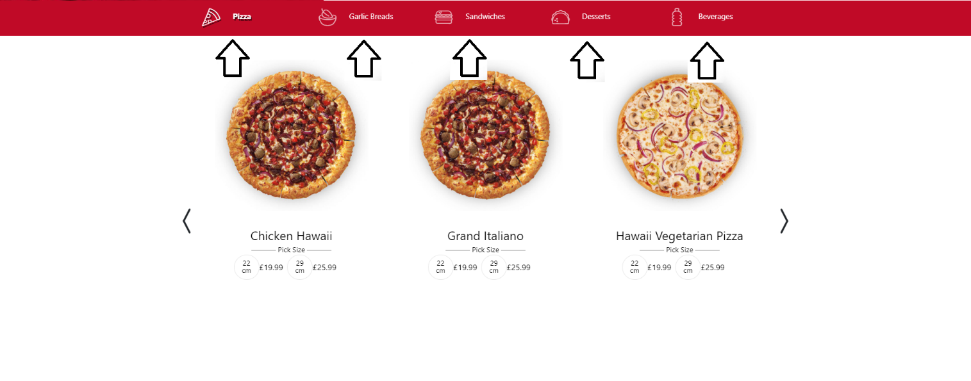

***Figure – 3***

*(Users see next products or previous products by clicking on* ***icon****)*

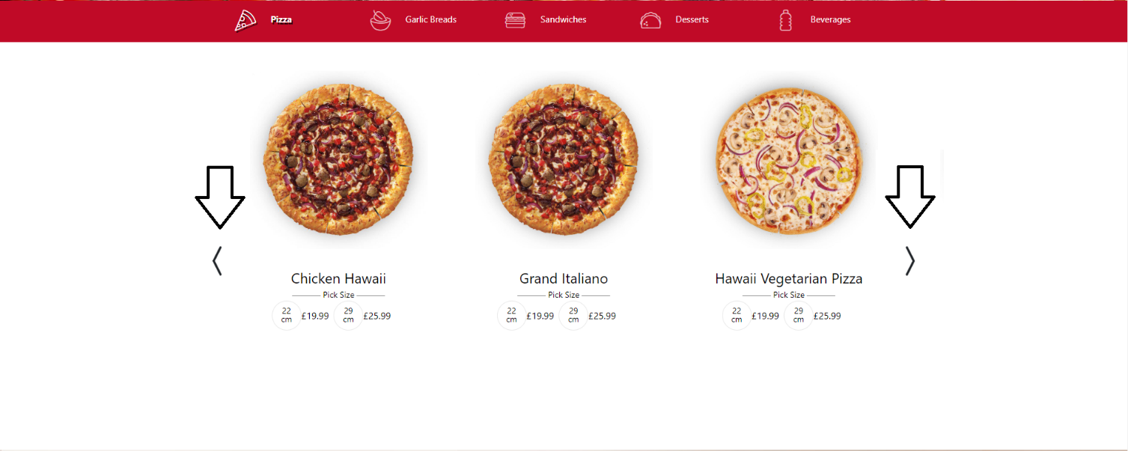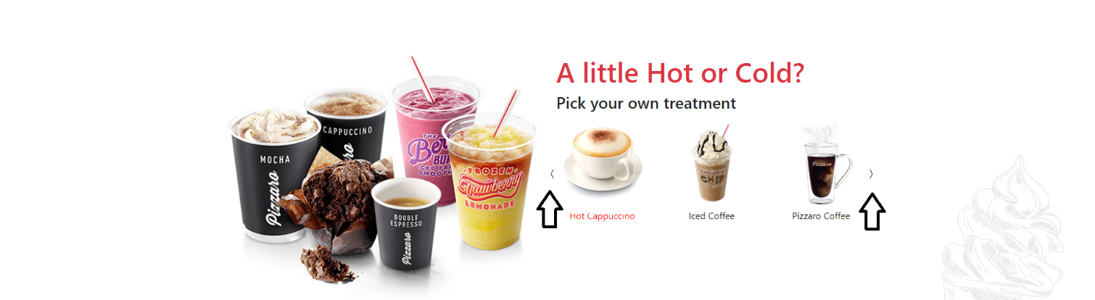

***Figure – 4***

*(Users move to Single product page of the product by clicking on* ***image or text****)*

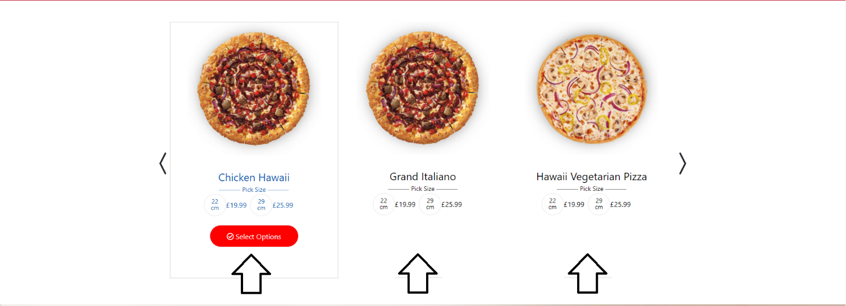

**List product page:**

This site show list product for choosing product and find product to buy

***Figure – 1***

*(Users change to Category of products by clicking on* ***icon*** *or* ***text****)*



***Figure – 2***

*(Users find product by typing on* ***the input tag****)*

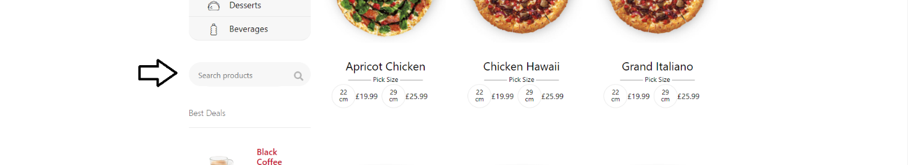

***Figure – 3***

*(Users see more product by clicking on* ***the pagination****)*



**Single product page:**

This site show detail infomation of the product

***Figure – 1***

*(Users zoom image by hovering on* ***main big image;*** *Users change image be showed by clicking on* ***any small image below;*** *Users change quantity of product by hovering on* ***main big image;*** *Users can see the cost on* ***posion of 2.9;****)*

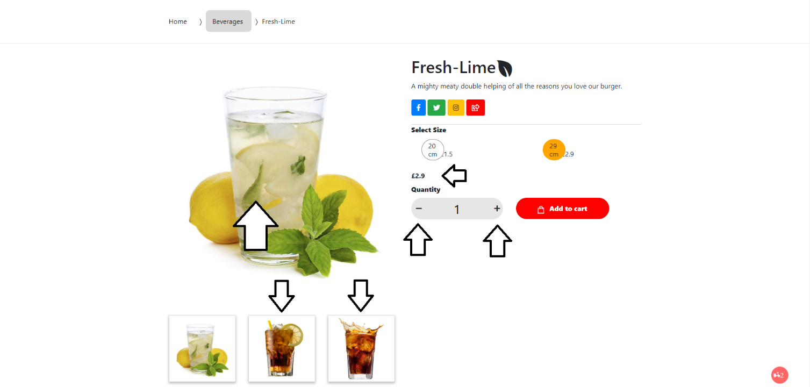

***Figure – 5***

*(User return List product page by clicking on this bock mark below)*

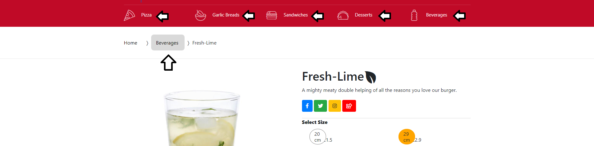

**Shopping cart page:**

This site show infomation of the products which you selected. User can go to this site by clicking cart icon on any page

***Figure – 1***

*(Users can remove the product, change quatity of products, press Check out button to jumb to Checkout page****;****)*

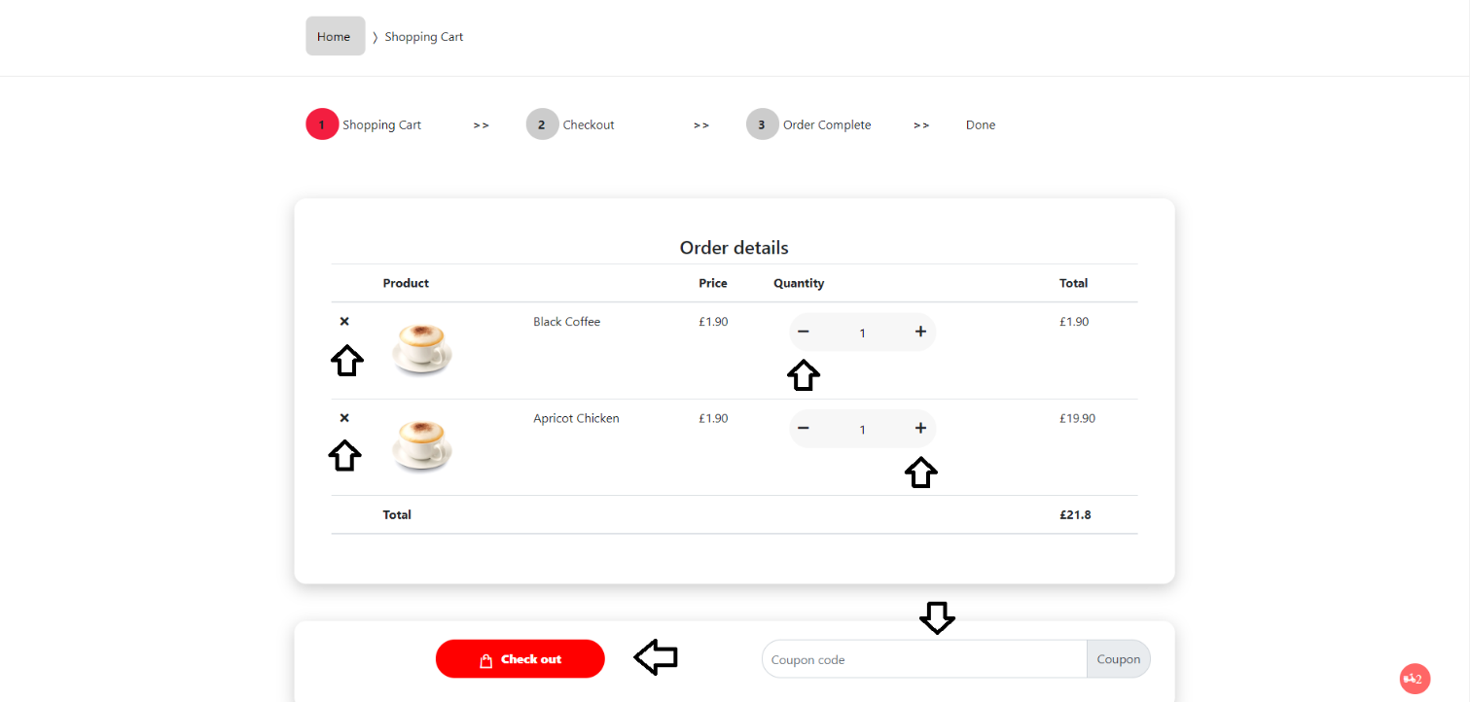

***Figure – 2***

*(Users fill in all input below then click Place order to get detail infomation of order****;****)*

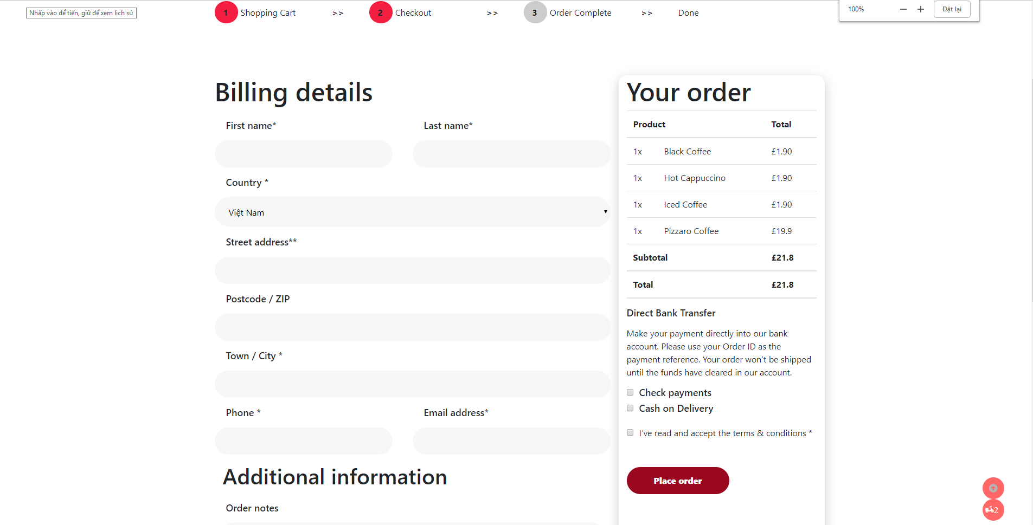

***Figure – 3***

*(Users get infomation of your order here****;****)*

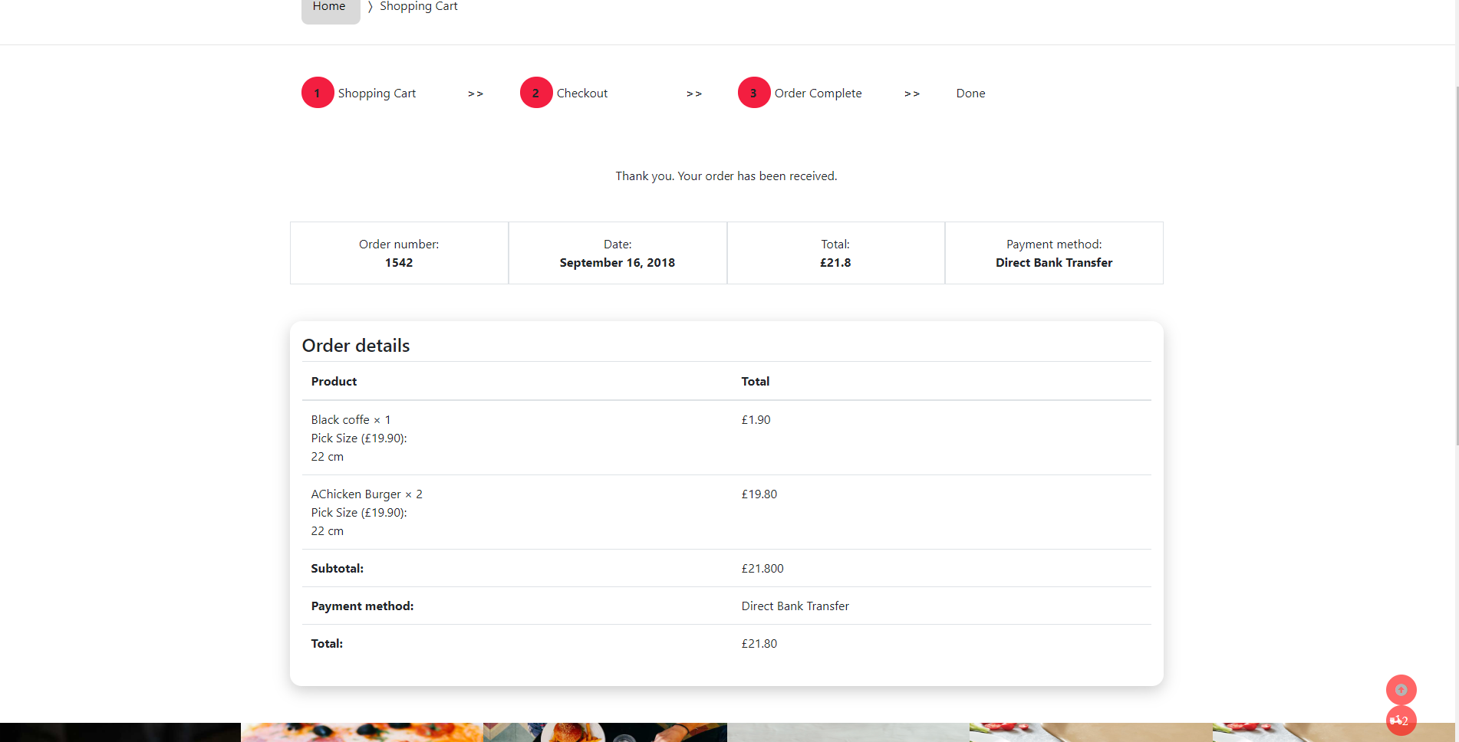

**Store location page:**

In this site, user can find store location to get product offline

***Figure – 1***

*(Users can see storelocation according to City by clicking on name of city then show map by clicking detail location****;****)*

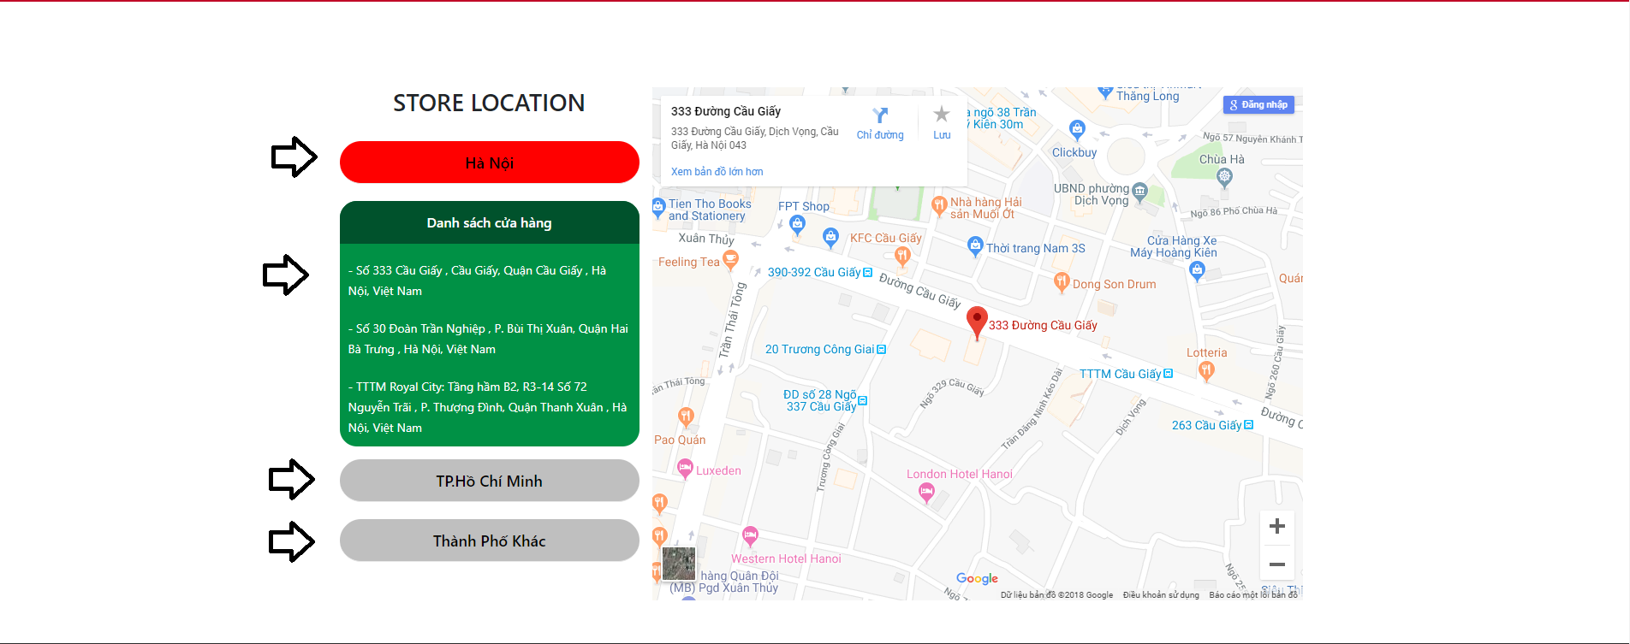

**Feedback page:**

In this site, user can send feedback to the store

***Figure – 1***

*(Users can chose emotion icon of user’s feedback, fill in all in put and then click send feedback****;****)*

